WE’VE SAVED THE CHANDOS ARMS!!!

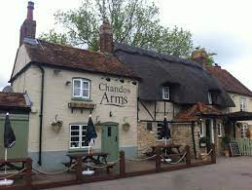

Oakley Parish Council are delighted to confirm we exchanged contracts to purchase The Chandos Arms on Friday 24th September, with the completion date set for Thursday 30th September.
This marks a huge moment for the pub and for the village, and is the start of an exciting future under community ownership.

The Chandos Needs YOU More Than Ever
We all want The Chandos Arms to be as successful as possible now it’s owned by the village. One way to be a part of that is heading in there for a drink or a meal once it’s re-opened.
In order to ensure its long-term success, we also need volunteers to come forward to form the new committee required to run the pub. This committee will set the community objectives, oversee refurbishment works, ensure the financial model works and appoint future landlords.
We want to ensure that this committee reflects the diversity of our village as well as having the right knowledge for success.
We are particularly keen to have people who have the following experience to bring to the team:
- Pub/Restaurant/Event Management
- Marketing
- Architecture or Planning
- HR
However, THE most important skillset we are looking for in volunteers is enthusiasm for making the pub the very best it can be for our village. Whether you’ve been a Chandos regular, occasional visitor or have never set foot in the pub – if you’re keen to be involved, we want to hear from you.

Please contact David Cherry (davecountyland@me.com, 07791 859317) or Jo Grey (JoGreyOPC@hotmail.com, 07715 516387) for more information by Tuesday 5th October. We will look to hold the first meeting soon after that date.

